From FOLU Net Sink to Net Zero: A Compliance-Based Sequestration Certificate Framework for Indonesia

Mezy Fadhilaª, Cendikia Raihan Albiruni^{b}, Ibrahim Al Fatih^{b}, Ramadhan Budianto^{b}

a. Environmental Science, Faculty of Science, The University of Melbourne

b. Energy Systems, Faculty of Engineering and IT, The University of Melbourne

Abstract
Indonesia’s net-zero emissions pathway relies heavily on the Forestry and Other Land Use (FOLU) sector, with national planning indicating that up to 60% of residual emissions in 2050 must be balanced by land-based sequestration. Under the Long-Term Strategy for Low Carbon and Climate Resilience, emissions are projected to peak at approximately 1 244 MtCO₂e in 2030 and decline to 540 MtCO₂e by 2050, implying a mitigation gap of roughly 704 MtCO₂e. This study evaluates the feasibility of meeting these targets through scenario-based sequestration analysis and proposes a compliance-based sequestration certificate scheme inspired by Australia’s Large-scale Generation Certificate (LGC) mechanism. Using IPCC Tier-1 assumptions, we assess land requirements under optimistic, moderate, and pessimistic risk scenarios, accounting for forest degradation, restoration lag, and uncertainty. Results indicate that while land availability is not a binding constraint, restoration requirements are highly sensitive to sequestration performance and governance risk. Adapting the institutional logic of LGCs to a non-offset, compliance-based sequestration certificate scheme could accelerate delivery of near-term FOLU Net Sink targets and support long-term net-zero outcomes, while strengthening national carbon accounting, private-sector engagement, and policy robustness.

1. Introduction
Indonesia hosts one of the world’s largest remaining tropical forest systems, encompassing extensive terrestrial forests, peatlands, and coastal ecosystems such as mangroves. These ecosystems store disproportionately large amounts of carbon relative to their global area and play a critical role in climate regulation and biodiversity conservation (Donato et al., 2011; FAO, 2020). Consequently, Indonesia has become a focal destination for international carbon offset initiatives, with multiple countries and private actors seeking mitigation opportunities through land-based sequestration projects (Newell et al., 2014).
Despite this ecological significance, Indonesia has experienced substantial forest loss over recent decades. Global assessments consistently rank Indonesia among the top five countries with the highest deforestation rates, driven by land-use change, commodity expansion, infrastructure development, and forest degradation (Curtis et al., 2018; Global Forest Watch, 2023). These trends raise fundamental concerns regarding the long-term reliability of forest-based mitigation strategies.
Under the LTS-LCCR, Indonesia projects national greenhouse gas emissions to peak around 2030 at approximately 1,244 MtCO₂e, before declining to 540 MtCO₂e by 2050 (Government of Indonesia, 2021). This trajectory implies a mitigation gap of approximately 704 MtCO₂e between peak emissions and mid-century targets. Notably, around 60% of this gap—equivalent to roughly 422 MtCO₂e—is expected to be addressed through the FOLU sector (FOLU KLHK, 202x). However, Indonesia’s FOLU Net Sink strategy targets net absorption of approximately 141 MtCO₂e by 2030 and 340 MtCO₂e by 2050 (KLHK, 2022), raising questions about whether current sequestration trajectories are sufficient to meet long-term expectations.
To address this challenge, Indonesia has articulated 15 mitigation actions under the FOLU Net Sink 2030 framework, spanning forest protection, restoration, sustainable management, and governance reforms. While comprehensive in scope, several of these actions—particularly plantation forest development, sustainable forest management, mangrove rehabilitation, and law enforcement—require significant financial mobilisation and long-term private-sector engagement. This paper explores whether a market-based sequestration certificate scheme could accelerate these mitigation pathways.

2. Analytical Framework and Methods
This study applies a Tier-1 carbon sequestration estimation approach consistent with the 2006 IPCC Guidelines for National Greenhouse Gas Inventories (AFOLU) to assess the scale of land-based mitigation required under Indonesia’s net-zero pathway. The Tier-1 approach relies on globally or regionally averaged default parameters and is widely used for initial feasibility assessments, policy scenario comparisons, and strategic planning, rather than detailed project-level accounting.

Estimation of Annual CO₂ Sequestration
Annual carbon sequestration is estimated by converting biomass growth into carbon dioxide equivalents using standard IPCC relationships. Annual CO₂ sequestration (ΔC) is calculated as:
$$ΔC=G×f_{C}×\frac{44}{12}$$
where $G$represents annual biomass growth (t dry matter ha⁻¹ yr⁻¹), $f_{C}$is the carbon fraction of biomass (assumed as 0.47 for terrestrial forests and 0.45 for mangrove ecosystems), and $44/12$is the molecular weight ratio used to convert carbon (C) to carbon dioxide (CO₂). These values follow IPCC default assumptions for tropical forest systems.

Inclusion of Below-Ground Biomass
To account for below-ground biomass contributions, total sequestration rates are adjusted using a root-to-shoot (R:S) ratio:
$$G_{total}=G_{AGB}×(1+R:S)$$
where $G_{AGB}$is the above-ground biomass growth rate and the root-to-shoot ratio (R:S) is assumed to be 0.37 for tropical moist forests, consistent with IPCC default values. This adjustment reflects the contribution of root systems to long-term carbon storage and improves consistency with national greenhouse gas inventory practices.

Scenario-Based Sequestration Assessment
Total sequestration requirements are derived by allocating a defined proportion of the national emissions reduction target to land-based mitigation and dividing this requirement by the effective sequestration rate over the analysis period (2030–2050). To reflect real-world uncertainty, the analysis applies risk scenarios (optimistic, moderate, pessimistic), which adjust effective sequestration rates downward to account for forest degradation, disturbance, and partial project failure.
The resulting estimates represent indicative, policy-scale outputs designed to evaluate feasibility, timing, and institutional implications rather than precise carbon accounting. The approach prioritises transparency and comparability across scenarios and aligns with the level of methodological detail typically required for conference-level policy analysis.

Methodological Scope and Limitations
As a Tier-1 assessment, this methodology does not incorporate site-specific growth rates, spatial heterogeneity, or dynamic ecosystem feedbacks. While this limits precision, it is appropriate for evaluating national-scale mitigation strategies and policy instruments. More detailed Tier-2 or Tier-3 approaches using country-specific data would be required for regulatory crediting or inventory reconciliation.

3. Indonesia’s FOLU Net Sink Policy Context
Indonesia’s FOLU Net Sink 2030 framework constitutes a central pillar of national climate mitigation strategy, positioning the forestry and land-use sector as a net absorber of greenhouse gas emissions by 2030 and a sustained mitigation contributor through mid-century. The framework outlines 15 mitigation actions spanning forest protection, ecosystem restoration, sustainable forest management, and institutional strengthening. These include reducing deforestation and degradation across mineral soils, peatlands, and mangroves; establishing plantation forests; rehabilitating degraded lands; restoring peat hydrology; implementing mangrove rehabilitation in post-mining areas; enhancing biodiversity conservation; expanding social forestry; strengthening supervision and law enforcement; and formalising Adat forests (KLHK, 2022).
Collectively, these measures are designed to deliver net negative emissions from the FOLU sector by 2030 and to progressively increase sequestration capacity toward 2050. However, evidence from both Indonesia and comparable tropical forest contexts indicates that the primary constraint is not biophysical potential but implementation capacity. Persistent barriers include limited and fragmented financing, overlapping institutional mandates, and uneven monitoring, reporting, and enforcement capacity, particularly for capital-intensive interventions such as plantation forestry, peatland restoration, and large-scale mangrove rehabilitation (Seymour & Busch, 2016; IPCC, 2022a).
While Indonesia has introduced emissions caps and begun developing domestic carbon market and certification mechanisms, these instruments remain insufficient in scale and incentive strength to mobilise private investment at the pace required to meet FOLU Net Sink targets. As a result, a significant gap persists between policy ambition and on-the-ground implementation (IFSA LC UGM, 2025). This gap highlights the need for a complementary, demand-driven policy instrument capable of translating national mitigation targets into predictable market signals for private actors. In this context, experience from certificate-based compliance mechanisms in the energy sector—most notably Australia’s Large-scale Generation Certificate (LGC) scheme—offers a relevant institutional reference for accelerating land-based mitigation through regulated market demand.

4. Lessons from Australia’s Large-scale Generation Certificate (LGC) Scheme
Under Australia’s Large-scale Renewable Energy Target (LRET), Large-scale Generation Certificates (LGCs) function as a market-based compliance instrument that converts government renewable energy targets into enforceable demand for renewable electricity. Administered by the Clean Energy Regulator, LGCs are issued to accredited large-scale renewable power stations on the basis of verified electricity generation, with each certificate representing one megawatt-hour (MWh) of eligible renewable output. Liable entities—primarily electricity retailers—are required to surrender a specified number of LGCs annually, creating a legally binding obligation that translates policy ambition into predictable market demand.
Empirical evaluations indicate that this mechanism played a critical role in accelerating large-scale wind and solar deployment in Australia by reducing revenue uncertainty and lowering investment risk, thereby mobilising private capital at scale (Nelson et al., 2019; Simshauser, 2018). Crucially, LGCs did not operate as voluntary offsets but as mandatory compliance units embedded within a regulated cap, ensuring that certificate demand was stable, cumulative, and directly linked to national targets. This regulatory design insulated renewable investment from short-term political and market volatility and provided a clear, long-term signal for project developers.
Several features of the LGC scheme are directly relevant to land-based mitigation. First, the use of standardised, verifiable units enabled transparent accounting and prevented double counting. Second, the separation of obligation (on liable entities) from delivery (by project developers) allowed mitigation outcomes to be achieved at least cost. Third, the phased and predictable nature of compliance facilitated gradual market maturation rather than abrupt policy shocks. These characteristics inform the proposed sequestration certificate scheme for Indonesia, where verified units of carbon sequestration could similarly be generated by restoration activities and surrendered by regulated entities to meet emissions obligations. By adopting the institutional logic of LGCs—compliance-driven demand, verification-based supply, and regulatory certainty—the proposed scheme aims to accelerate FOLU mitigation while strengthening governance and private-sector participation.

5. Proposed Sequestration Certificate Scheme for Indonesia
Building on the institutional logic of Australia’s Large-scale Generation Certificate (LGC) scheme, this study proposes a sequestration certificate mechanism designed to accelerate Indonesia’s FOLU-based mitigation while maintaining regulatory integrity. The proposed scheme is structured as a compliance-oriented instrument, rather than a voluntary offset, and is intended to complement existing emissions caps and national mitigation targets.
Under this framework, the government establishes sectoral emissions caps and designates regulated entities—such as energy producers, extractive industries, or other high-emitting sectors—as liable parties. These entities are required to either undertake eligible land-based mitigation activities directly or surrender verified sequestration certificates to meet their regulatory obligations. This mirrors the LGC model in which demand for certificates is created through legally binding compliance requirements rather than voluntary participation.
On the supply side, restoration and land-management entities—including plantation forest operators, mangrove rehabilitation projects, and peatland restoration initiatives—generate sequestration certificates following verification by the Ministry of Environment and Forestry (KLHK). Certificates are issued on the basis of measured and verified carbon sequestration outcomes, ensuring consistency with national greenhouse gas accounting and preventing double-counting. Importantly, the separation between certificate obligation (regulated entities) and certificate delivery (restoration actors) allows mitigation outcomes to be achieved at least cost, a design feature that proved critical to the effectiveness of the LGC scheme.
To manage institutional capacity and market maturity, the scheme is envisaged to progress through three implementation phases: an initial voluntary phase to establish methodologies and build confidence; a semi-compliance phase targeting selected sectors; and a full compliance phase integrating sequestration certificates into the national emissions regulatory framework. This phased approach reflects lessons from Australia’s renewable energy transition, where gradual escalation of compliance obligations reduced investment risk and facilitated private-sector participation.
By translating national FOLU mitigation targets into predictable market demand, the proposed sequestration certificate scheme directly addresses the implementation gap identified in Indonesia’s FOLU Net Sink strategy. The scheme is particularly suited to accelerating capital-intensive mitigation actions—such as plantation forest establishment, sustainable forest management, mangrove rehabilitation, and strengthened enforcement—where public financing alone has proven insufficient. In this way, the proposed mechanism adapts the core institutional strengths of the LGC framework to Indonesia’s land-use context, aligning private investment incentives with long-term national climate objectives.
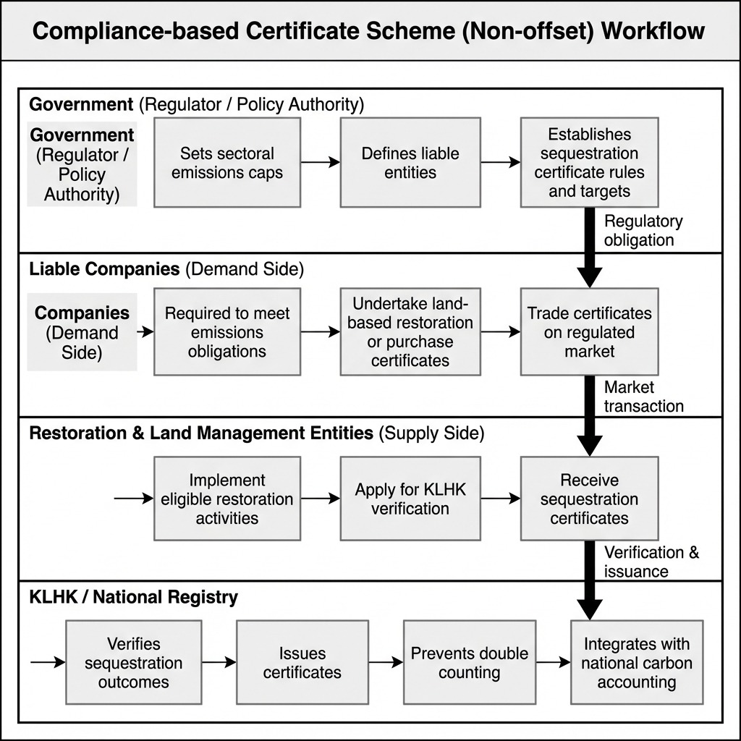
Figure 1. Proposed adaptation scheme for a sequestration certificate mechanism in Indonesia. The framework illustrates a compliance-based, non-offset certificate system in which the government establishes emissions caps and designates liable entities, creating regulated demand for sequestration certificates. Restoration and land-management entities generate certificates following verification by the Ministry of Environment and Forestry (KLHK), with issuance integrated into national carbon accounting to prevent double counting. The scheme separates regulatory obligation from mitigation delivery, adapting institutional design principles from Australia’s Large-scale Generation Certificate (LGC) framework to accelerate land-based mitigation under Indonesia’s FOLU Net Sink strategy.
Figure 1 illustrates the proposed adaptation scheme for a sequestration certificate mechanism in Indonesia. The workflow is structured around a compliance-based framework, in which the government establishes emissions caps and designates liable entities, creating regulated demand for sequestration certificates. Restoration and land-management entities supply certificates following verification by the Ministry of Environment and Forestry (KLHK), ensuring alignment with national carbon accounting and preventing double counting. This structure mirrors the institutional logic of Australia’s Large-scale Generation Certificate scheme by separating regulatory obligation from mitigation delivery, thereby enabling least-cost mitigation through market mechanisms.

6. Indicative Results and Scenario Implications

6.1 Net-Zero Pathway and the Role of Land-Based Sequestration
Figure 2 illustrates Indonesia’s indicative pathway toward net-zero emissions, decomposing gross emissions, existing forest sink capacity, new restoration efforts, and non-land-based mitigation. Gross emissions decline from approximately 1,200 MtCO₂e in the early 2020s toward the 2050 target of 540 MtCO₂e, consistent with national long-term strategy assumptions. Existing forest sink capacity contributes substantially in the near term but decays over time at an assumed rate of 2% per year due to ongoing deforestation and degradation. New restoration efforts enter with a lagged growth profile, reflecting cohort-based planting and forest maturation dynamics. Together with mitigation from energy, transport, and industry (assumed to contribute 40% of total reductions), these components drive the net carbon balance toward zero by mid-century. This decomposition highlights the structural dependence of Indonesia’s net-zero pathway on sustained land-based sequestration rather than short-term offsets

National Net Zero Strategy Roadmap (2023-2050)

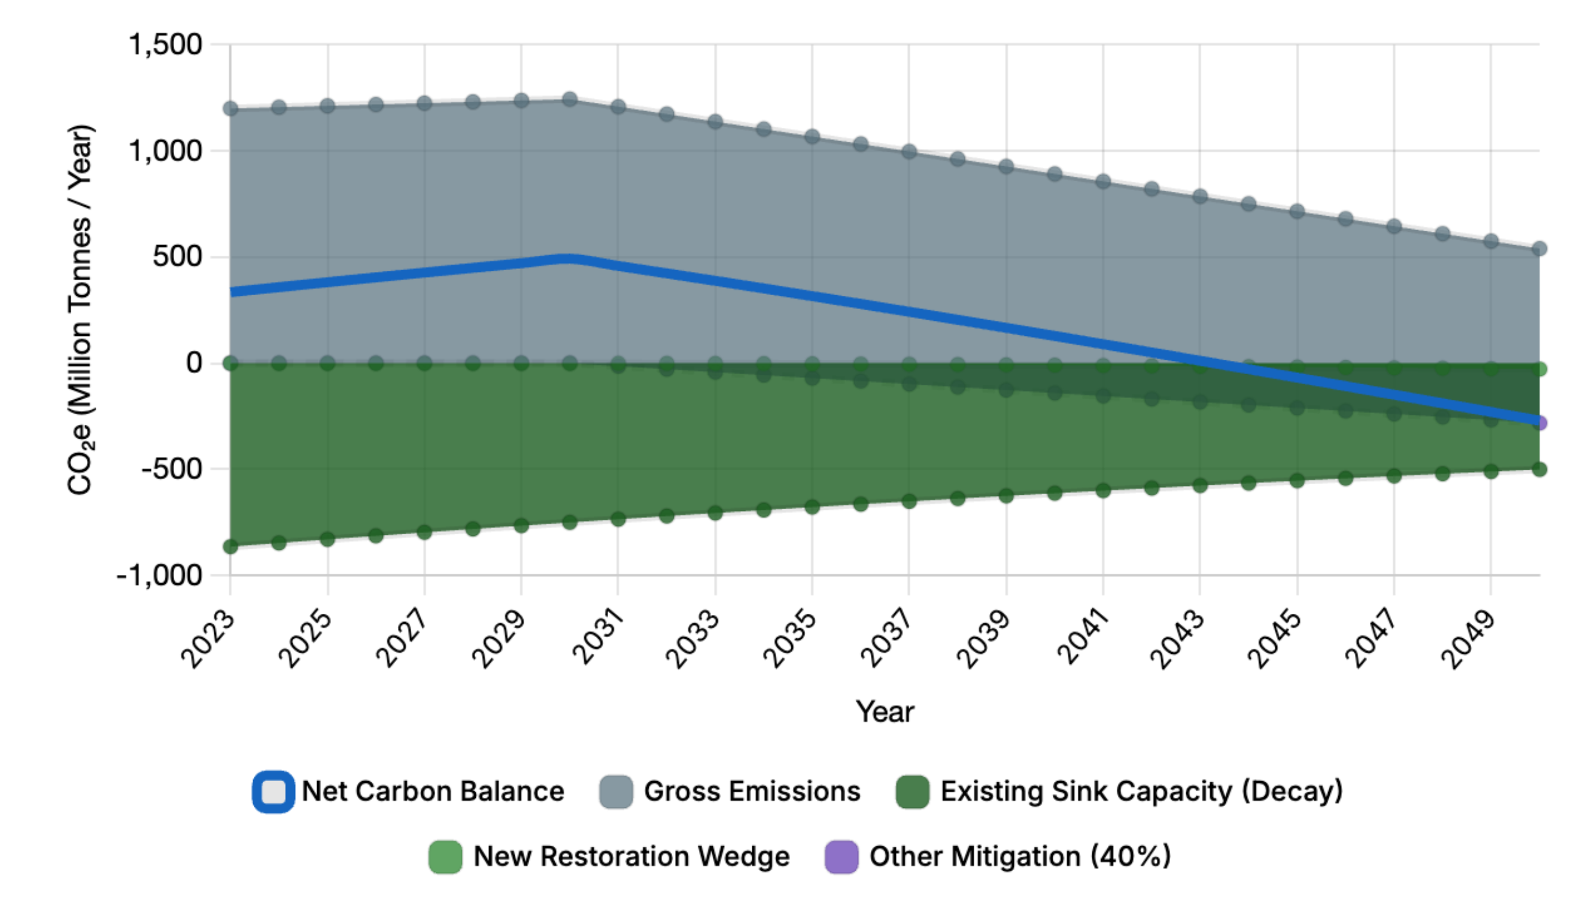

Figure 2. Indicative national net-zero pathway for Indonesia (2023–2050), showing gross emissions, declining existing forest sink capacity, new restoration contributions with growth lag, mitigation from non-land-based sectors, and resulting net carbon balance. Grey indicates gross emissions, dark green existing sinks, light green new restoration, purple other mitigation, and the blue line the net balance

6.2 Scale of Land Requirement under Risk Scenarios
Figure 3 compares Indonesia’s existing forest and coastal areas with the additional land area required to meet sequestration targets under three risk scenarios. Even under pessimistic assumptions, the additional land required represents a small fraction of Indonesia’s current forest estate, indicating that feasibility is constrained less by land availability than by institutional and financial capacity. However, higher risk assumptions substantially increase restoration requirements, underscoring the sensitivity of land-based mitigation outcomes to permanence, degradation, and implementation failure.

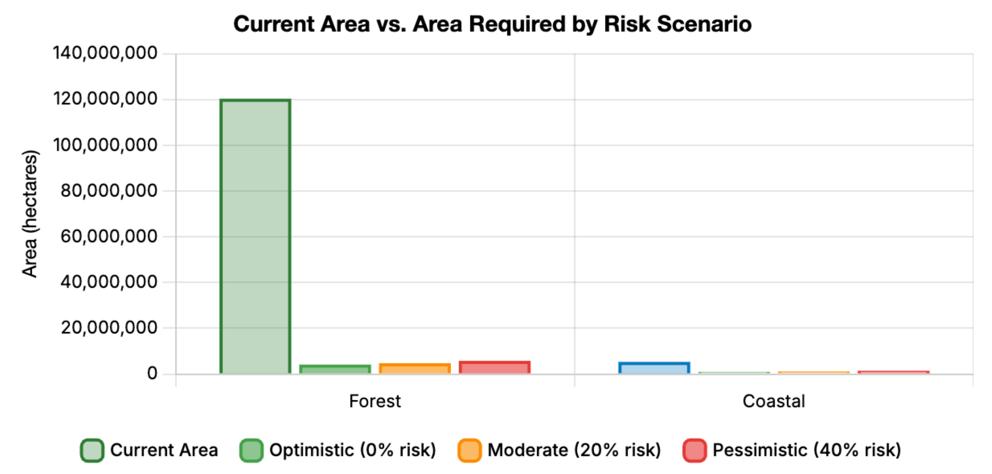

Figure 3. Comparison of Indonesia’s current forest and coastal areas with additional restoration area required under optimistic (0%), moderate (20%), and pessimistic (40%) risk scenarios. Higher risk assumptions increase land requirements to compensate for potential sequestration losses

6.3 Temporal Dynamics of Restoration Effort
Figure 4 presents the cumulative reforestation and restoration trajectory required between 2030 and 2050. Under all scenarios, required restoration increases steadily over time, reflecting both delayed carbon uptake and compounding risk buffers. Divergence between optimistic, moderate, and pessimistic scenarios widens toward 2050, illustrating how early uncertainty translates into substantially different long-term land requirements. This dynamic reinforces the importance of early, sustained investment in restoration to avoid back-loading mitigation effort.

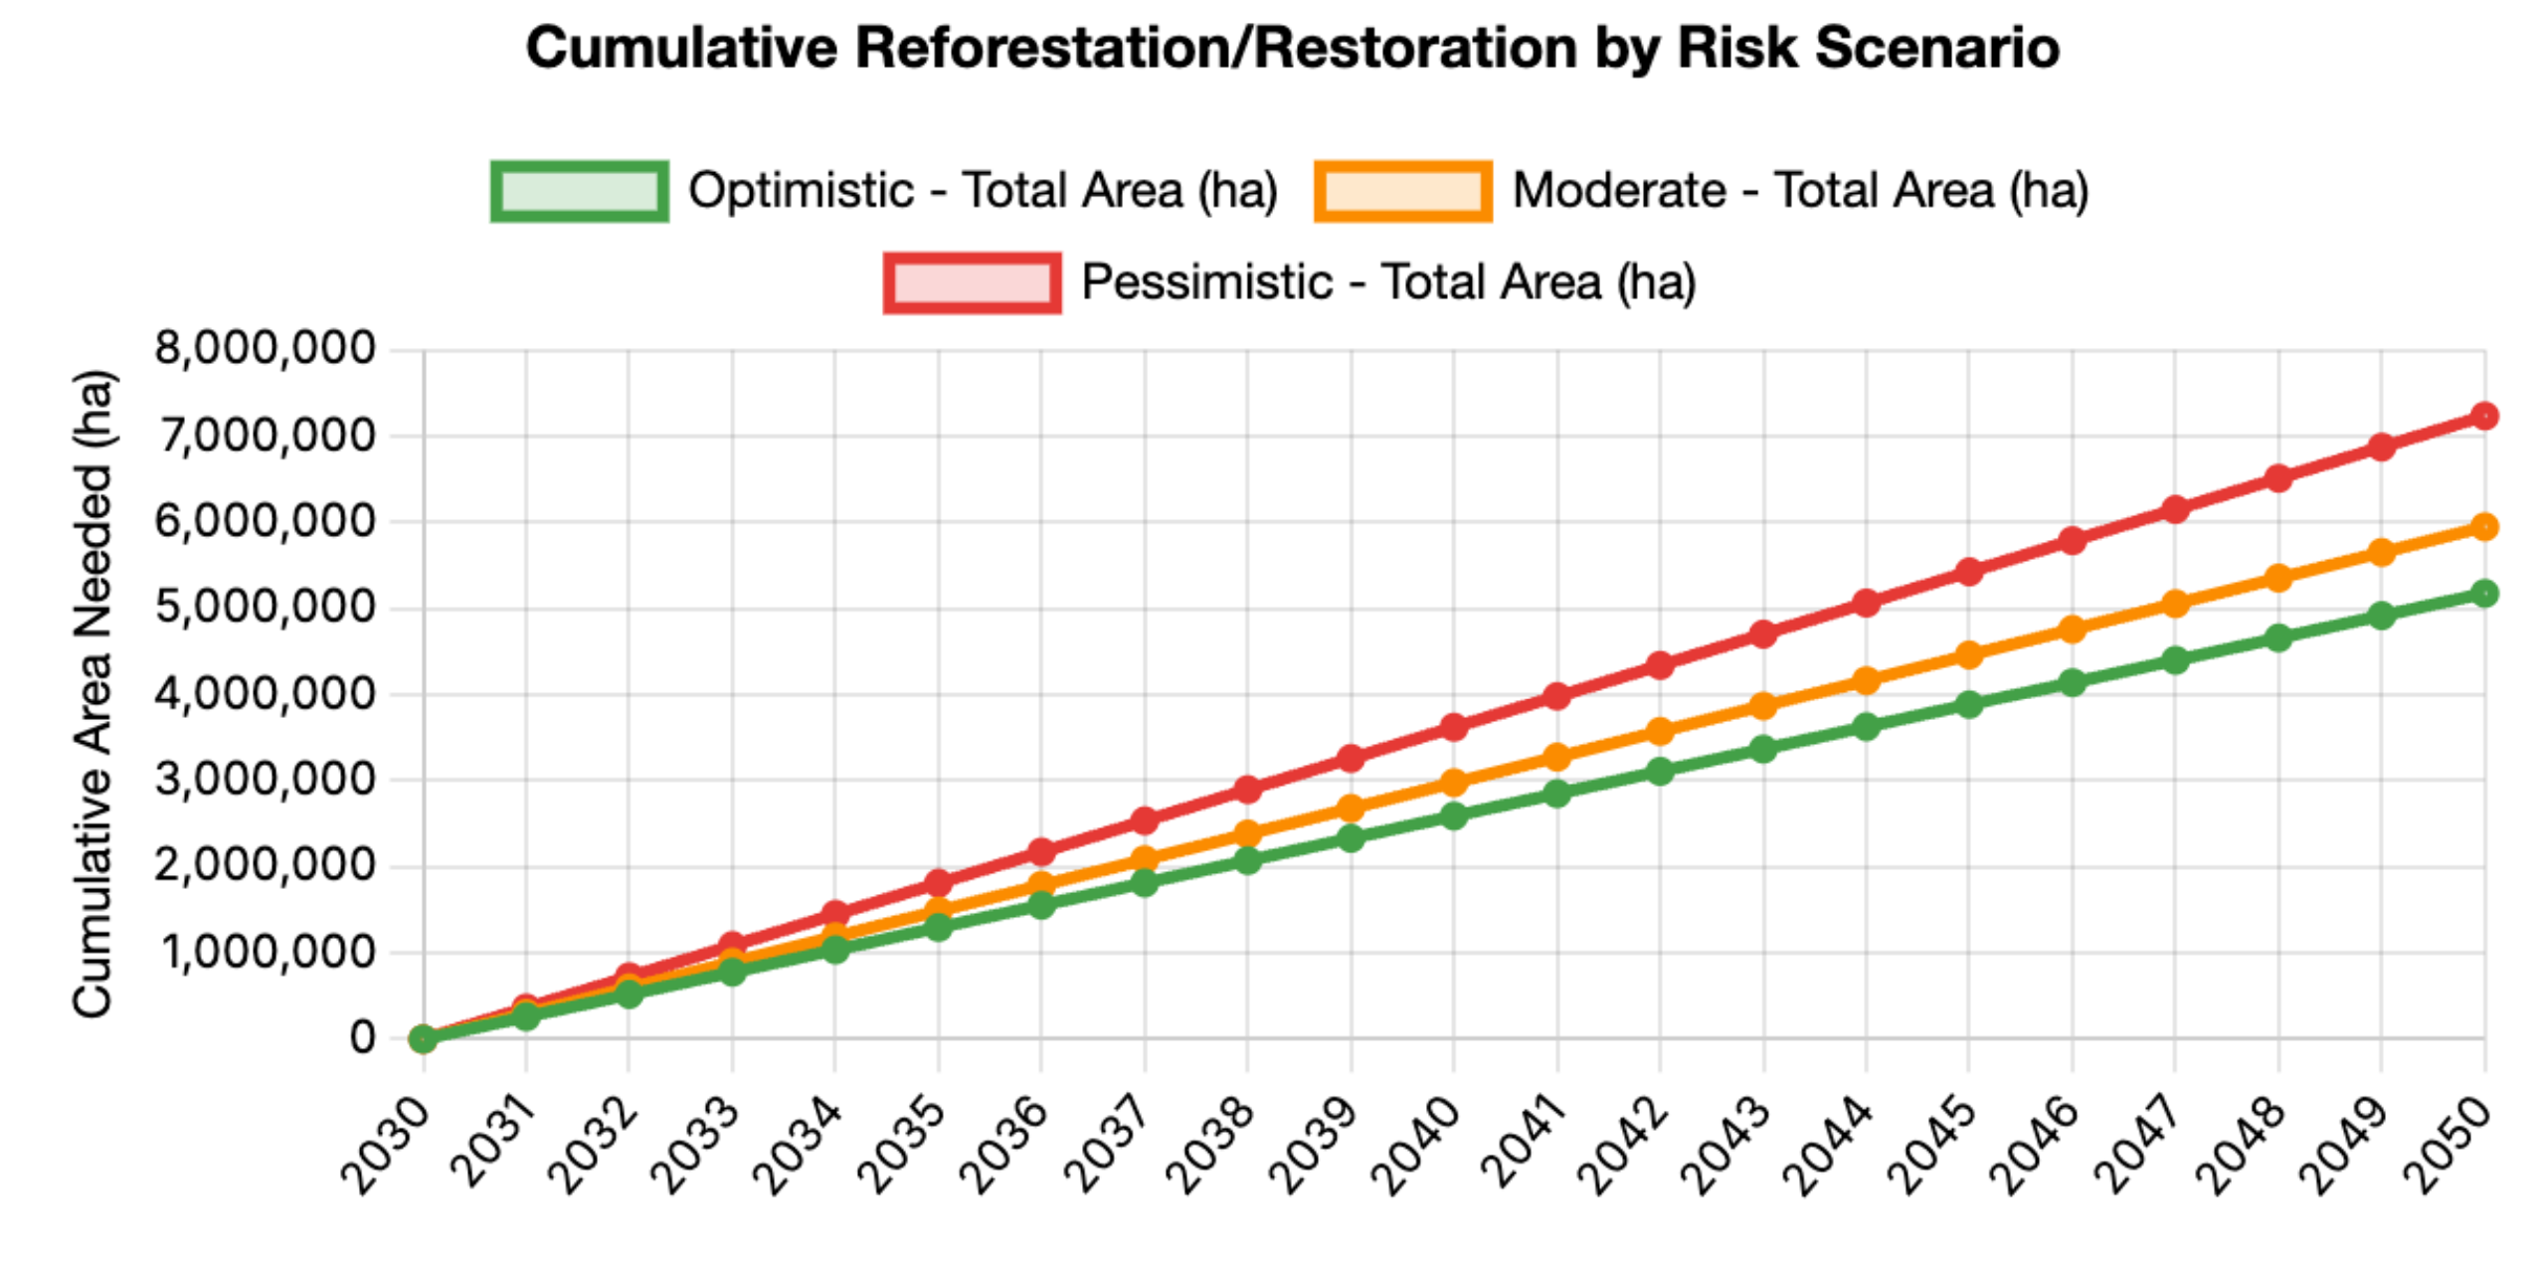

Figure 4. Cumulative reforestation and coastal restoration required between 2030 and 2050 under alternative risk scenarios. Divergence over time reflects compounding uncertainty and delayed carbon uptake from restoration activities

6.4 Composition of Restoration and Policy Robustness
Figure 5 disaggregates total land requirements by ecosystem type, showing that approximately 80% of restoration effort is allocated to terrestrial forests and 20% to coastal and mangrove systems. While coastal ecosystems contribute a smaller share of total area, their high sequestration efficiency makes them strategically important. Finally, Figure 6 shows that risk assumptions affect land requirements rather than the emissions reduction trajectory itself, which converges on the 2050 target across scenarios. Taken together, these results suggest that adopting the moderate (20% risk) scenario as a planning baseline, while considering pessimistic assumptions for policy robustness, provides a defensible basis for designing compliance-based sequestration instruments.

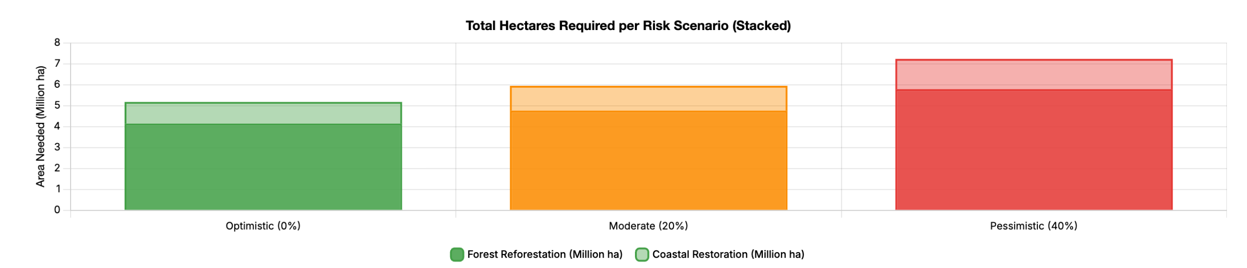

Figure 5. Total land area required for sequestration under each risk scenario, disaggregated into terrestrial forest reforestation and coastal/mangrove restoration. Taller stacked bars indicate greater land demand under higher risk assumptions

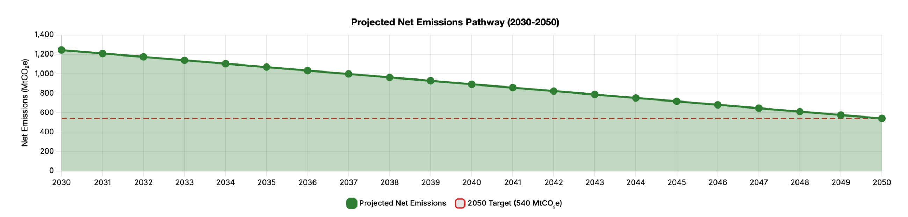Figure 6. Projected net emissions trajectory (2030–2050) relative to the 2050 emissions target. Risk scenarios affect land area requirements but do not alter the emissions pathway itself

7. Discussion

7.1 Interpreting the Indicative Results in a Policy Context
The results presented in this study illustrate that Indonesia’s net-zero pathway is structurally feasible only under sustained and large-scale land-based mitigation, consistent with national planning assumptions under the FOLU Net Sink 2030 framework. The wedge-style decomposition demonstrates that while gross emissions decline steadily toward the 2050 target, the contribution of existing forest sinks diminishes over time due to ongoing deforestation and degradation. This finding aligns with global assessments showing that unmanaged forest sinks cannot be assumed to remain stable over multi-decadal horizons (IPCC, 2022a; FAO, 2020).
New restoration cohorts therefore play a critical compensatory role, but their contribution is delayed by ecological growth dynamics. The assumed establishment lag reflects well-documented patterns of forest carbon accumulation, where meaningful sequestration typically occurs several years after planting (Chapin et al., 2002; Pan et al., 2011). This temporal mismatch between emissions reductions and sequestration uptake reinforces the importance of early action and long-term policy certainty—conditions that are difficult to achieve through voluntary or short-term financing mechanisms alone.

7.2 Land Availability versus Implementation Capacity
Across all scenarios, the additional land area required for restoration represents a relatively small fraction of Indonesia’s total forest and coastal estate. This suggests that biophysical land availability is not the binding constraint. Instead, the dominant challenges lie in institutional coordination, financing, permanence, and enforcement—findings that echo comparative analyses of tropical forest mitigation efforts globally (Seymour & Busch, 2016; IPCC, 2022a).
The sensitivity of land requirements to degradation and sequestration rate assumptions highlights how weak enforcement or project underperformance can significantly increase the scale of restoration needed. This reinforces the argument that mitigation strategies must prioritise governance quality and durability, rather than simply expanding nominal restoration targets.

7.3 Implications of Risk Scenarios for Policy Design
The divergence between optimistic, moderate, and pessimistic scenarios illustrates how uncertainty compounds over time. While the moderate (20%) risk scenario provides a reasonable planning baseline, the upper bound represented by the pessimistic scenario offers a more robust reference for policy design under adverse conditions. This approach is consistent with IPCC guidance, which recommends explicitly accounting for uncertainty and adopting conservative assumptions where mitigation failure would have high systemic costs (IPCC, 2006; IPCC, 2022b).
Importantly, the emissions trajectory itself remains fixed across scenarios, indicating that uncertainty primarily affects how much land must be mobilised, not whether net-zero is theoretically achievable. This distinction underscores the value of compliance-based instruments that can scale demand in response to observed performance rather than relying on static targets.

7.4 Relevance of Compliance-Based Certificates for FOLU Mitigation
The sensitivity analysis shows that total land requirements are highly responsive to sequestration rates, emissions targets, and the proportion of mitigation allocated to the FOLU sector, while being less sensitive to parameters such as the root-to-shoot ratio. This ranking mirrors findings in the broader sequestration literature, where growth rates and permanence dominate uncertainty relative to biomass allocation parameters (Penman et al., 2003; Mokany et al., 2006).
These results support the case for a compliance-based sequestration certificate scheme, adapted from energy-sector mechanisms such as Australia’s Large-scale Generation Certificate (LGC) system. By embedding demand for sequestration within emissions caps, such a scheme can dynamically adjust investment incentives in response to uncertainty, degradation risk, and policy ambition—features that voluntary offset markets typically lack (Newell et al., 2014; IPCC, 2022b).

7.5 Uncertainty, Limitations, and Sensitivity Considerations
This study is subject to several important limitations and sources of uncertainty. First, the analysis relies on IPCC Tier-1 default sequestration rates, which do not capture spatial heterogeneity in forest productivity, species composition, or management practices. While appropriate for national-scale feasibility assessment, these assumptions introduce uncertainty at regional and project scales (IPCC, 2006).
Second, sequestration rates for coastal ecosystems exhibit particularly wide uncertainty ranges due to variability in mangrove type, sediment dynamics, and hydrological conditions (Alongi, 2014). Third, degradation rates are highly sensitive to policy effectiveness, enforcement capacity, and disturbance regimes, all of which are difficult to project over multi-decadal horizons (FAO, 2020).
The sensitivity analysis indicates that ±20% variation in sequestration rates, emissions targets, or the share of mitigation allocated to the FOLU sector can alter total land requirements by approximately ±20–25%, classifying these parameters as high-sensitivity drivers. In contrast, parameters such as the root-to-shoot ratio exhibit comparatively low influence on aggregate outcomes, consistent with prior carbon accounting studies (Mokany et al., 2006).
Additional structural assumptions—including linear emissions decline, full additionality of restoration, permanence of carbon stocks, absence of saturation effects in mature forests, and static climate conditions—further constrain interpretation. These simplifications are common in strategic policy analyses but imply that results should be interpreted as indicative ranges rather than precise forecasts (Penman et al., 2003; Grace, 2004; IPCC, 2022a).

7.6 Policy Implications
Economy-wide emissions caps beyond the power sector.
Figures 1 and 5 show that Indonesia’s net-zero pathway is structurally fixed by the emissions target, while uncertainty primarily affects the scale of land required (Figures 2–4). This implies that limiting binding caps to the power sector—currently centred on PLN—constrains compliance demand and weakens investment signals. Extending caps to additional high-emitting sectors (industry, extractives, transport) would broaden regulated demand for sequestration certificates, improving robustness under higher-risk scenarios (IPCC, 2022a; Nelson et al., 2019).
Integration with national MRV and inventories.
The sensitivity of land requirements to sequestration performance (Figures 2–4) underscores the need for credible verification. Linking certificate issuance to Indonesia’s forest monitoring system SIPASHUT and recognised standards such as Verra would enhance data consistency, prevent double counting, and strengthen claims toward Indonesia’s Nationally Determined Contribution (IPCC, 2006; IPCC, 2022a).
Accelerating restoration across regions and ecosystems.
Figures 2–4 indicate that required restoration is feasible in aggregate but sensitive to degradation risk, implying that spatially diversified restoration across regions and ecosystem types is preferable to concentrated projects. A compliance-based certificate scheme would incentivise distributed restoration aligned with FOLU Net Sink priorities, reducing systemic risk (FAO, 2020; Seymour & Busch, 2016).
Private-sector accountability and least-cost mitigation.
Because uncertainty affects land requirements rather than the emissions trajectory (Figure 5), embedding certificates within a compliance framework channels private investment dynamically as performance is observed. Liable entities face clear incentives to reduce emissions directly (renewables, efficiency) or procure verified sequestration, mirroring evidence from certificate-based energy policies that mobilise capital at scale (Nelson et al., 2019).
Employment and social co-benefits.
The cumulative restoration trajectories (Figure 3) imply sustained, labour-intensive activity over decades, supporting rural employment and green jobs consistent with FOLU Net Sink objectives. Distributed restoration further enables participation by local and Indigenous communities through verified delivery pathways (FAO, 2020; IPCC, 2022b).

8. Conclusions
This study examined the feasibility of Indonesia’s reliance on land-based mitigation under the FOLU Net Sink 2030 and long-term net-zero strategy, and evaluated the role of a compliance-based sequestration certificate scheme in addressing implementation gaps. Scenario results indicate that while land availability is not a binding constraint, restoration requirements are highly sensitive to sequestration performance, degradation risk, and policy ambition. Uncertainty therefore affects the scale and timing of land mobilisation rather than the emissions trajectory itself.
Drawing on lessons from Australia’s Large-scale Generation Certificate scheme, the proposed non-offset sequestration certificate framework embeds land-based mitigation within emissions caps and national accounting systems, creating predictable demand for verified outcomes. If effectively integrated with national monitoring and verification, the scheme could accelerate FOLU mitigation, strengthen inventory credibility, and deliver co-benefits in employment and ecosystem restoration.
References:
Alongi, D. M. (2014). Carbon cycling and storage in mangrove forests. Annual Review of Marine Science, 6, 195–219. https://doi.org/10.1146/annurev-marine-010213-135020
Chapin, F. S., Matson, P. A., & Mooney, H. A. (2002). Principles of terrestrial ecosystem ecology. Springer. https://doi.org/10.1007/978-1-4419-9504-9
Food and Agriculture Organization of the United Nations. (2020). Global forest resources assessment 2020: Main report. FAO. https://doi.org/10.4060/ca9825en
Grace, J. (2004). Understanding and managing the global carbon cycle. Journal of Ecology, 92(2), 189–202. https://doi.org/10.1111/j.0022-0477.2004.00874.x
Intergovernmental Panel on Climate Change. (2006). 2006 IPCC guidelines for national greenhouse gas inventories: Volume 4—Agriculture, forestry and other land use. IPCC. https://www.ipcc-nggip.iges.or.jp/public/2006gl/
Intergovernmental Panel on Climate Change. (2022a). Climate change 2022: Mitigation of climate change (Working Group III contribution to the Sixth Assessment Report). Cambridge University Press. https://doi.org/10.1017/9781009157926
Intergovernmental Panel on Climate Change. (2022b). Climate change 2022: Impacts, adaptation and vulnerability (Working Group II contribution to the Sixth Assessment Report). Cambridge University Press. https://doi.org/10.1017/9781009325844
Kementerian Lingkungan Hidup dan Kehutanan. (2022). Indonesia’s FOLU Net Sink 2030: Indonesia’s climate actions towards 2030. KLHK.
Mokany, K., Raison, R. J., & Prokushkin, A. S. (2006). Critical analysis of root:shoot ratios in terrestrial biomes. Global Change Biology, 12(1), 84–96. https://doi.org/10.1111/j.1365-2486.2005.001043.x
Nelson, T., Reid, C., McNeill, J., & Simshauser, P. (2019). Energy-only markets and renewable energy targets: Complementary policy or policy collision? Energy Economics, 82, 273–286. https://doi.org/10.1016/j.eneco.2019.04.018
Newell, R. G., Pizer, W. A., & Raimi, D. (2014). Carbon market design, stability, and reform. Energy Policy, 75, 16–22. https://doi.org/10.1016/j.enpol.2014.09.010
Pan, Y., Birdsey, R. A., Fang, J., Houghton, R., Kauppi, P. E., Kurz, W. A., Phillips, O. L., Shvidenko, A., Lewis, S. L., Canadell, J. G., Ciais, P., Jackson, R. B., Pacala, S. W., McGuire, A. D., Piao, S., Rautiainen, A., Sitch, S., & Hayes, D. (2011). A large and persistent carbon sink in the world’s forests. Science, 333(6045), 988–993. https://doi.org/10.1126/science.1201609
Penman, J., Gytarsky, M., Hiraishi, T., Krug, T., Kruger, D., Pipatti, R., Buendia, L., Miwa, K., Ngara, T., Tanabe, K., & Wagner, F. (2003). Good practice guidance for land use, land-use change and forestry. IPCC. https://www.ipcc-nggip.iges.or.jp/public/gpglulucf/
Seymour, F., & Busch, J. (2016). Why forests? Why now? The science, economics, and politics of tropical forests and climate change. Center for Global Development. https://doi.org/10.1596/978-1-4648-0992-2

